Chapter test

Chapter 6 Water and the intermolecular forces

Name:

Class:

Time permitted: 30 minutes

|  |  |  |  |  |
| --- | --- | --- | --- | --- |
|  | Section | Number of questions | Marks available | Marks achieved |
| A | Multiple choice | 15 | 15 |  |
| B | Short answer | 5 | 15 |  |
|  | Total |  | 30 |  |

Grade:

Scale:

|  |  |  |  |  |  |  |  |  |  |  |  |  |  |
| --- | --- | --- | --- | --- | --- | --- | --- | --- | --- | --- | --- | --- | --- |
| A+ | 29–30 | A | 26–28 | B | 23–25 | C | 19–22 | D | 15–18 | E | 9–14 | UG | 0–8 |

Comments:

Section A Multiple choice (15 marks)

Section A consists of 15 questions, each worth one mark. Each question has only one correct answer. Circle the correct answer. Attempt all questions. Marks will not be deducted for incorrect answers. You are advised to spend no more than 15 minutes on this section.

1 What shape are water molecules?

A Linear

B Trigonal planar

C Bent

D Tetrahedral

2 Which of the following processes does not involve ‘breaking’ or ‘forming’ intermolecular bonds?

A Ice melting

B Evaporating water from a salt solution

C Decomposing water into hydrogen and oxygen

D Water droplets condensing on a cold mirror

3 Which of the following is the correct valence structure diagram for chlorine gas?

A 

B 

C 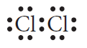

D 

4 A molecule with a tetrahedral shape is identified as having:

A 4 electron pairs and 0 lone pairs on the central atom.

B 3 electron pairs and 1 lone pair on the central atom.

C 4 electron pairs and 1 lone pair on the central atom.

D 4 electron pairs and 2 lone pairs on the central atom.

5 What is the maximum number of covalent bonds that a nitrogen atom can form?

A 3

B 2

C 1

D 0

6 In which of the following substances are bonding electrons shared evenly?

A Hydrogen chloride

B Water

C Ammonia

D Fluorine gas

7 The following all possess polar bonds, but which is a polar molecule?

A C2H4

B CCl4

C NH3

D CO2

8 The intermolecular forces in order of increasing strength are:

A dipole–dipole < dispersion < hydrogen bonds.

B dipole–dipole > dispersion > hydrogen bonds.

C dispersion < dipole–dipole < hydrogen bonds.

D dispersion > dipole–dipole > hydrogen bonds.

9 When bonded with a hydrogen atom, which of the following atoms does not form a hydrogen bond?

A Nitrogen

B Chlorine

C Oxygen

D Fluorine

10 Which of the following has the lowest boiling point?

A HF

B H2S

C HCl

D CH4

11 Which type of force or bond exists between all covalent molecular substances?

A Dispersion forces

B Dipole–dipole forces

C Hydrogen bonds

D Covalent bonds

12 Capillary action helps plants take up soluble nutrients from the soil. Which of these forces is not involved in capillary action?

A Surface tension

B Cohesive force

C Adhesive force

D Gravitational force

13 Ionic compounds that are referred to as hydrated:

A are ionic salts that can be dissolved in water.

B have waters of crystallisation attached.

C have had waters of crystallisation removed by heating.

D all contain hydrogen bonds between the ions and the water molecules surrounding them.

14 Surfactants:

A decrease the wettability of a liquid.

B interrupt the surface tension of water.

C are hydrophobic.

D are hydrophilic.

15 The type of chromatography used to analyse the presence of drugs or the pigment in plants is:

A gas chromatography.

B high-performance liquid chromatography.

C thin-layer chromatography.

D paper chromatography.

Section B Short answer (15 marks)

Section B consists of five questions. Write your answers in the spaces provided. You are advised to spend 20 minutes on this section.

1 Describe the three types of intermolecular force. (3 marks)

2 a Draw an electron dot diagram for the ammonia molecule. (1 mark)

b Identify the shape of the ammonia molecule. Justify your answer.   
 (2 marks)

3 Below is a graph showing the boiling points of hydrides of groups 14–17. Discuss the shape of the graphs for the boiling points in group 14 and group 16.

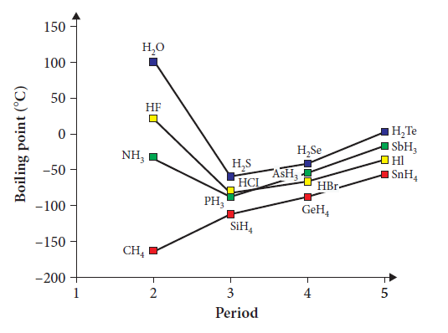

(3 marks)

4 Use a labelled diagram to describe why ethanol is so useful as a solvent.   
 (3 marks)

5 Use a table to contrast gas chromatography and high-performance liquid chromatography. (3 marks)

End of test (30 marks)